**Rajan Gautam**

**19BCP101**

**Div. II, CE 19**

**SOT, PDPU**

**Pandit Deendayal Energy University**

**School of Technology**

**Design Pattern and Thinking (20CP210P)**

**B. Tech - Computer Science & Engineering (Sem-IV)**

**Table of Contents**

**Lab 2 Assignment: Builder Design Pattern for Car details 1**

**AIM: To write a Java Program to implement Builder Design Pattern Car details 1**

**WITHOUT BUILDER PATTERN - CODE: 1**

**MyCar.java 1**

**MainBuilder.java 2**

**WITHOUT BUILDER PATTERN - SCREENSHOT OF IDE: 2**

**WITHOUT BUILDER PATTERN - SCREENSHOT OF OUTPUT: 3**

**WITH BUILDER PATTERN - CODE: 4**

**MyCar.java 4**

**CarBuilder.java 4**

**MainBuilder.java 6**

**WITH BUILDER PATTERN - SCREENSHOT OF IDE: 7**

**WITH BUILDER PATTERN - SCREENSHOT OF OUTPUT: 8**

# Lab 2 Assignment: Builder Design Pattern for Car details

## AIM: To write a Java Program to implement Builder Design Pattern Car details

## WITHOUT BUILDER PATTERN - CODE:

### MyCar.java

1. **package Builder_Car;**
3. **public class MyCar {**
4. **private String carBrand;**
5. **private String carModel;**
6. **private int carModelYear;**
7. **private int carID;**
8. **private String carColor;**
9. **private Double carMass;**
10. **private String carEngine;**
11. **private Double carMileage;**
13. **public MyCar(String carBrand, String carModel, int carModelYear, int carID, String carColor, double carMass, String carEngine, double carMileage)**
14. **{**
15. **super();**
16. **this.carBrand = carBrand;**
17. **this.carModel = carModel;**
18. **this.carModelYear =carModelYear;**
19. **this.carID = carID;**
20. **this.carColor = carColor;**
21. **this.carMass = carMass;**
22. **this.carEngine = carEngine;**
23. **this.carMileage = carMileage;**
24. **}**
26. **@Override**
27. **public String toString()**
28. **{**
29. **return "Car[Brand: " + carBrand + ", Model: " + carModel + ", Model Year: " + carModelYear**
30. **+ ", ID: " + carID + ", Color: " + carColor + ", Mass: " + carMass**
31. **+ " kg, Engine: " + carEngine + ", Mileage: " + carMileage + " kmph]";**
32. **}**
33. **}**

### MainBuilder.java

1. **package Builder_Car;**
3. **public class MainBuilder {**
5. **public static void main(String[] args)**
6. **{**
7. **MyCar carDetails = new MyCar("Mercedes", "Benz", 2021, 12332, "White", 5000, "Diesel", 30);**
8. **System.out.println(carDetails);**
9. **}**
10. **}**

## 

## WITHOUT BUILDER PATTERN - SCREENSHOT OF IDE:

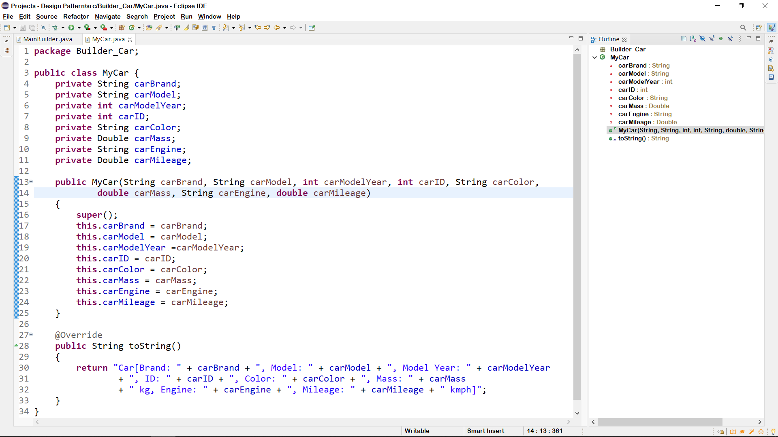

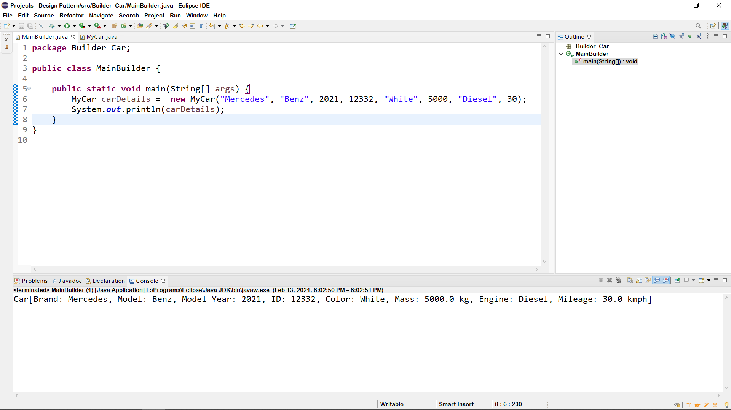

## WITHOUT BUILDER PATTERN - SCREENSHOT OF OUTPUT:

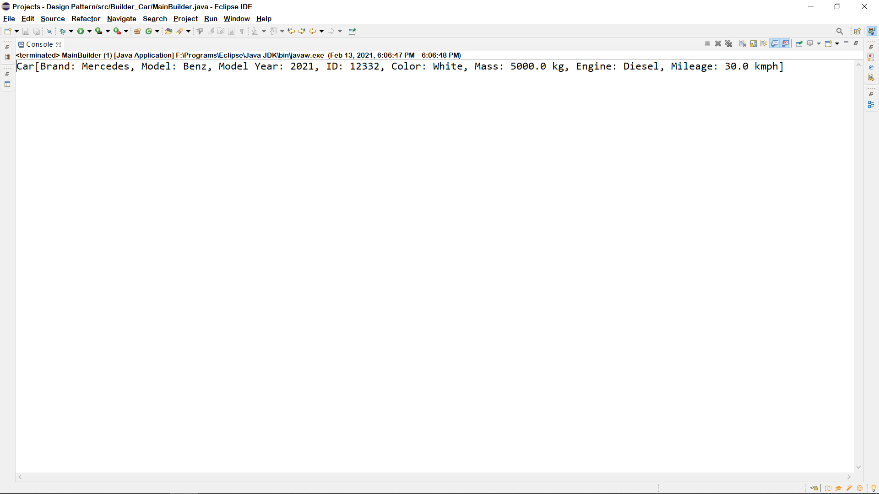

## WITH BUILDER PATTERN - CODE:

### MyCar.java

1. **package Builder_Car;**
3. **public class MyCar {**
4. **private String carBrand;**
5. **private String carModel;**
6. **private int carModelYear;**
7. **private int carID;**
8. **private String carColor;**
9. **private Double carMass;**
10. **private String carEngine;**
11. **private Double carMileage;**
13. **public MyCar(String carBrand, String carModel, int carModelYear, int carID, String carColor, double carMass, String carEngine, double carMileage)**
14. **{**
15. **super();**
16. **this.carBrand = carBrand;**
17. **this.carModel = carModel;**
18. **this.carModelYear =carModelYear;**
19. **this.carID = carID;**
20. **this.carColor = carColor;**
21. **this.carMass = carMass;**
22. **this.carEngine = carEngine;**
23. **this.carMileage = carMileage;**
24. **}**
26. **@Override**
27. **public String toString()**
28. **{**
29. **return "Car[Brand: " + carBrand + ", Model: " + carModel + ", Model Year: " + carModelYear**
30. **+ ", ID: " + carID + ", Color: " + carColor + ", Mass: " + carMass**
31. **+ " kg, Engine: " + carEngine + ", Mileage: " + carMileage + " km]";**
32. **}**
33. **}**

### CarBuilder.java

1. **package Builder_Car;**
3. **public class CarBuilder {**
4. **private String carBrand;**
5. **private String carModel;**
6. **private int carModelYear;**
7. **private int carID;**
8. **private String carColor;**
9. **private double carMass;**
10. **private String carEngine;**
11. **private double carMileage;**
13. **public CarBuilder setcarBrand(String carBrand) {**
14. **this.carBrand = carBrand;**
15. **return this;**
16. **}**
18. **public CarBuilder setcarModel(String carModel) {**
19. **this.carModel = carModel;**
20. **return this;**
21. **}**
23. **public CarBuilder setcarModelYear(int carModelYear) {**
24. **this.carModelYear = carModelYear;**
25. **return this;**
26. **}**
28. **public CarBuilder setcarID(int carID) {**
29. **this.carID = carID;**
30. **return this;**
31. **}**
33. **public CarBuilder setcarColor(String carColor) {**
34. **this.carColor = carColor;**
35. **return this;**
36. **}**
38. **public CarBuilder setcarMass(double carMass) {**
39. **this.carMass = carMass;**
40. **return this;**
41. **}**
43. **public CarBuilder setcarEngine(String carEngine) {**
44. **this.carEngine = carEngine;**
45. **return this;**
46. **}**
48. **public CarBuilder setcarMileage(double carMileage) {**
49. **this.carMileage = carMileage;**
50. **return this;**
51. **}**
53. **public MyCar getCarDetails() {**
54. **return new MyCar(carBrand, carModel, carModelYear, carID, carColor, carMass, carEngine, carMileage);**
55. **}**
56. **}**

### MainBuilder.java

1. **package Builder_Car;**
3. **public class MainBuilder {**
5. **public static void main(String[] args) {**
7. **MyCar car1 = new CarBuilder().setcarBrand("Ferrari").setcarModel("Portofino").setcarMileage(21).getCarDetails();**
9. **MyCar car2 = new CarBuilder().setcarBrand("Mercedes").setcarColor("White").setcarMass(5000).setcarEngine("Diesel").setcarMileage(19).getCarDetails();**
11. **MyCar car3 = new CarBuilder().setcarBrand("Maruti").setcarEngine("Engine").setcarColor("Red").setcarMass(6200).setcarID(126435).setcarModelYear(2015).getCarDetails();**
13. **MyCar car4 = new CarBuilder().setcarBrand("Bugatti").setcarColor("Blue").setcarID(543412).setcarModelYear(2019).setcarMass(4900).setcarMileage(20).getCarDetails();**
15. **MyCar car5 = new CarBuilder().setcarBrand("Lamborghini").setcarColor("Blue").setcarID(154642).setcarModelYear(2018).setcarModel("Aventador SVJ").setcarMileage(17).getCarDetails();**
17. **MyCar car6 = new CarBuilder().setcarBrand("Tesla").setcarModel("S").setcarColor("Silver").setcarEngine("Electric").setcarModelYear(2020).setcarMileage(20).getCarDetails();**
19. **System.out.println(car1);**
20. **System.out.println(car2);**
21. **System.out.println(car3);**
22. **System.out.println(car4);**
23. **System.out.println(car5);**
24. **System.out.println(car6);**
25. **}**
26. **}**

## WITH BUILDER PATTERN - SCREENSHOT OF IDE:

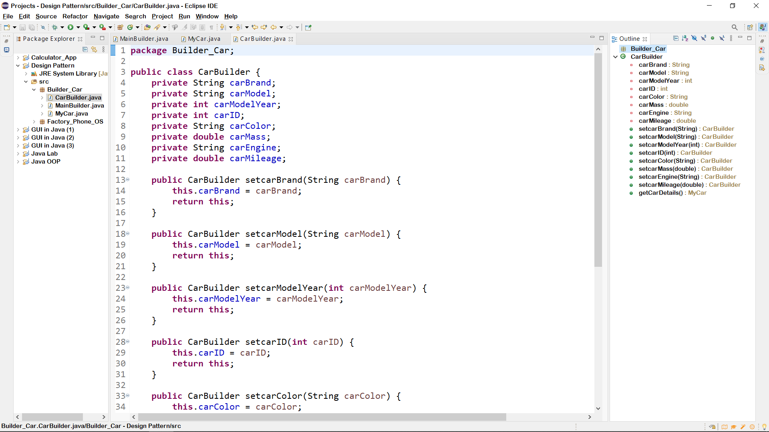

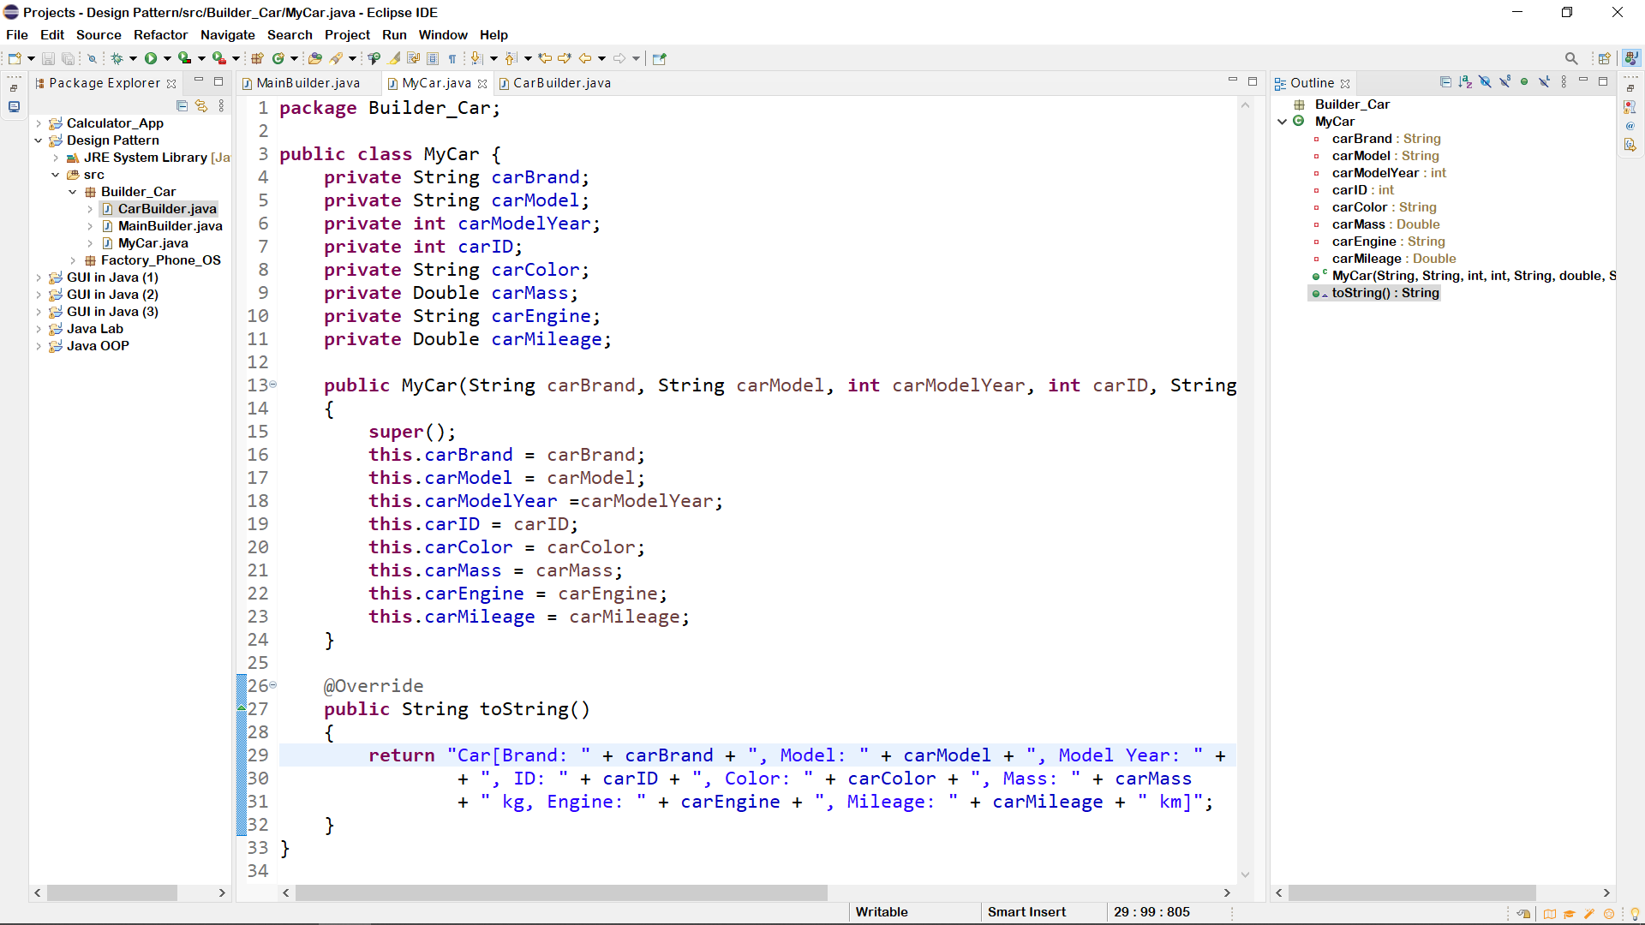

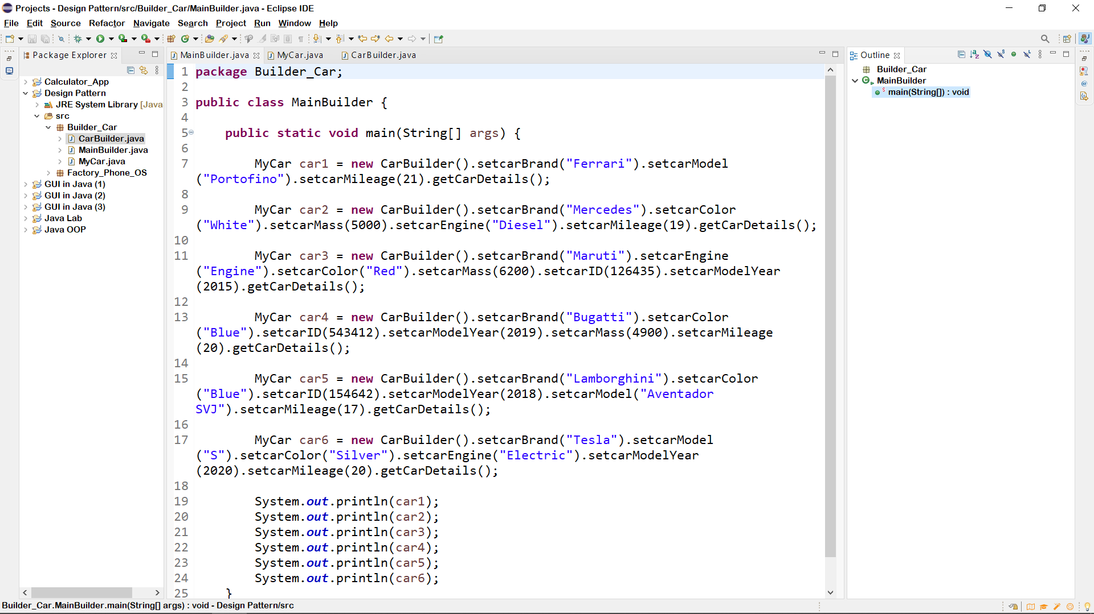

## WITH BUILDER PATTERN - SCREENSHOT OF OUTPUT:

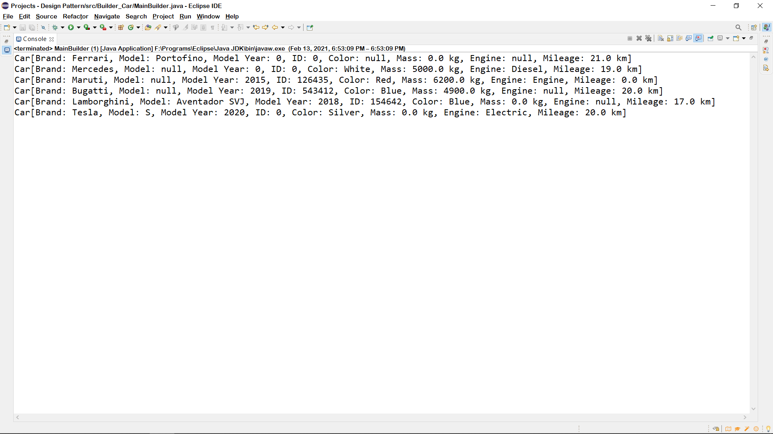

**GitHub Link:** [**https://github.com/rgautam320/Design-Pattern-Lab/tree/main/Builder_Car**](https://github.com/rgautam320/Design-Pattern-Lab/tree/main/Builder_Car)